LECTIO DIVINA 14th April 2024 3r^{d} Sunday of Easter B
Read, Reflect and Pray the Sunday Scriptures
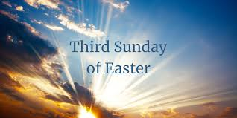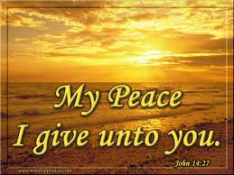

- Song & Opening Prayer Come Holy Spirit; fill the hearts of your people
And enkindle in them the fire of your love.
Send forth your spirit and we shall be recreated
And you shall renew the face of the earth…..
2. Quiet time (1 minute)
Let us quieten our minds for prayer, and try to become aware that God is present:

- In my daily activities
- In my joys and frustrations
- In my successes and failures

- In those I love, and, In my “enemies”
- In those gathered here
- In the word of God that we encounter tonight

- Reading of the Psalm (together) 4. Listen to the Readings
5. Look for a word or phrase from the readings that “strikes” you. Share it. (Optional)
(No comment or discussion at this time please.)

6. DISCUSSION / COMMENTS / SHARED MEDITATION ON THE READINGS

7. Reflection & Action: a) What relevance, (if any), do these scripture readings have to my life?
or b) Can I find a practical response in the coming week, to these readings and reflections ?
or c) Can I find a meaningful word or phrase that I could ponder during the coming week.?

8. Prayer: LET US PRAY:
- For the Church: that the Spirit will open our minds to understand the Scriptures and empower us to share the message of God’s love and forgiveness with all whom we encounter. Lord hear us.
- For the grace of forgiveness: that we will be open to Gods free and generous forgiveness and strive to forgive others as we have been forgiven. Lord hear us.
- For the gift of faith: that we will trust God more fully in every aspect of our lives and grow in our confidence that God will never abandon us even when our prayers do not seem to be answered. Lord hear us.
- For all who are broken and wounded: that they may find healing in Christ and that God will help us recognize the wounded Christ as our brothers and sisters. Lord hear us.
- Open our ears to your word and our eyes to recognise the face of Christ among us, and in all of creation that we may respond appropriately. Lord hear us.
- For Peace: that God will give courage to all who are working for peace and open hearts to new opportunities to resolve differences. Lord hear us.
- For all who have died: that they may be one with Christ for all eternity. Lord hear us.
(Any other prayer that anyone would like to share)
9. Silence (1 minute)
Let us sit a while in silence and gratitude,….in the presence of Christ in the Word,…..in the presence of Christ in each other,………in the presence of Christ in our hearts, …and try to become more open and aware of God’s love in the coming week.

10. Closing Song, 11. Prayer (Our Father) and Blessing. 12. Sign of Peace

